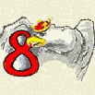SZKOŁA PODSTAWOWA NR 8 IM. ORLĄT LWOWSKICH W ZAMOŚCIU

MIĘDZYSZKOLNY KONKURS Z JĘZYKA ANGIELSKIEGO
DLA SZKÓŁ PODSTAWOWYCH
POWIATU ZAMOJSKIEGO
ROK 2011/2012

Termin: 02.03.2012 Godzina: 12.00
Czas: 20 min
PART I

Elementy wiedzy o krajach anglojęzycznych

Wybierz poprawną odpowiedź i zaznacz odpowiednią literę na karcie odpowiedzi. (max:22 pkt)

Example | The Cathedral of St Peter and St. Paul ..........................................
A) is in London B) is situated in New York
C) was built in 1826 D) is known also as Washington National Cathedral

1. | What is the traditional English breakfast?
1. | A) Eggs, bacon, sausages, fried bread, mushrooms, baked beans  B) Pizza C) Toast, jam and tea D) pancakes with honey
2. | 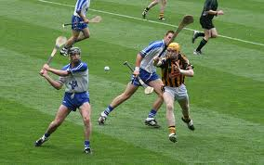 Which is not England's national sport?
2. | A) football B) cricket C) hurling D) rugby
3. | Which country is not in Great Britain?
3. | A) Wales B) Northern Ireland C) The Republic of Ireland D) England
4. | The traditional symbol of Ireland is not ........................ 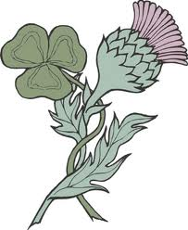
4. | A) A celtic cross B) A daffodil C) A shamrock D)harp
5. | Official languages of Ireland are ................
5. | A) English only B) Irish only C) Irish and French D) Irish and English
6. | The head of state in Canada is .............................
6. | A) Stephen Harper B) Queen Elizabeth II C) Queen Victoria D) President Barack Obama
7. | 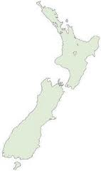Which country looks like a boot on the map?
7. | A) Australia B) Great Britain C) New Zealand D) Canada
8. | The Union Jack is the name of:
8. | A) The USA flag B) the UK flag C) a football club D) a football club
9. | Ulster is a name of:
9. | A) northern part of England B) national flower of Scotland C) Northern Ireland  D) One of the British Isles
10. | 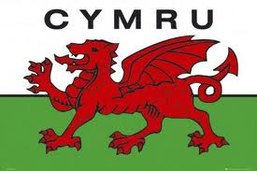A red dragon is a symbol of: .......................
10. | A) Ireland B) Wales C) England D) Scotland
11. | Wimbledon is the oldest of all the major............. tournaments beginning in 1877.
11. | A) tennis B) cricket C) rugby D) soccer
12. | 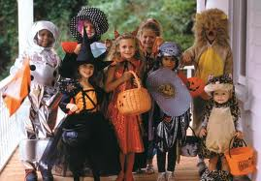 When in Britain you will hear "trick or treat"on:...........................
12. | A) 5th November B) 31st October C) 1st November D) 24th December
13. | 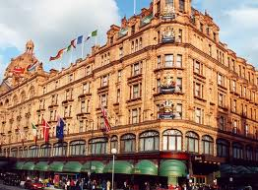 London's most exclusive department store is called:
13. | A) Harrods B) C&A C) Marks&Spencer D) Mack & Dave's Department Store
14. | 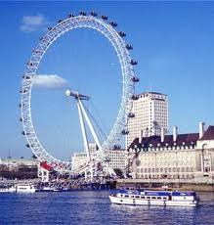 ......................- London’s most modern landmark, is the world’s biggest wheel which can carry 800 passengers at a time on a thirty-minute ride.
14. | A) Blackpool Tower B) The London Eye  C) The Palace of Westminster D) Tower of London
15. | 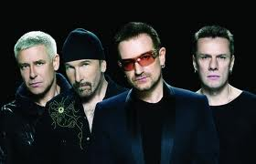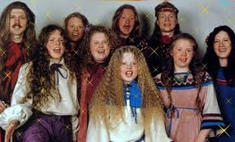  These musicians come from Ireland:
15. | A) U2 and Kelly Family, B) the Beatles and the Rolling Stones  C) Selena Gomez and Madonna. D) Justin Bieber and Rihanna
 | 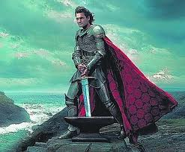 What is the name of King Arthur's sword?
 | A) Excalibur B) Excavator C) Durendal D) Hrunting
17. | 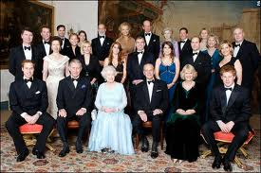 What is the surname of the British Royal Family?
17. | A) Stuart B) Winsdor C) Johnson D) Turpin
18. | Columbus Day - an American public holiday is held on to honour Christopher Columbus on:
18. | A) December 2 B) October 12, C)July 4 D) September 2
19. | The ship that took a group of English settlers to Plymouth, Massachusetts in the US in 1620 was
19. | A) Queen Elizabeth B) Mayflower,  C) Queen Mary D) Titanic
20. | 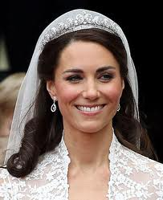 Who is Prince William married to?
20. | A) Princess Diana B) Camilla Rosemary C) Catherine Middleton D) Catherine Howard
21. | 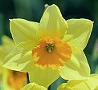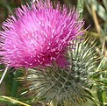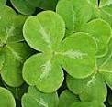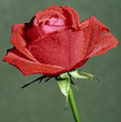  The national flower of England is ................., of Scotland is ......................, of Wales is .................. and of Northern Ireland is ..............................
21. | A) rose/thistle/daffodil/shamrock B) shamrock/leek/bluebell/maple  C) hyacinth/ orchid/ poppy/primrose D) sunflower/ thistle/ tulip/rose
22. | The capital city of New Zealand is ................... and the capital of Australia is ...................  The capital of Canada is ........................and the capital of the USA is .......................
22. | - Ottawa/ Canberra / Washington D.C. / Wellington  - New York / London / Aukland / Washington  - Wellington / Canberra / Ottawa / Washington D.C.  - Melbourne / Toronto / Chicago / Washington

CZĘŚĆ I ODPOWIEDZI
ELEMENTY WIEDZY O KRAJACH ANGLOJĘZYCZNYCH

1. | 2. | 3. | 4. | 5. | 6. | 7. | 8. | 9. | 10. | 11. | 12. | 13. | 14. | 15. | 16. | 17. | 18. | 19. | 20.
A | C | C | B | D | B | C | B | C | B | A | B | A | B | A | A | B | B | B | C
21.
A
22. C

