YOUNG CHAMPIONS OF ENGLISH

MIĘDZYSZKOLNY KONKURS Z JĘZYKA ANGIELSKIEGO
DLA SZKÓŁ PODSTAWOWYCH
ROK 2012/2013
Termin: 22.03.2013 Godzina: 10.00

Czas: 60min
PART II

Wszystkie odpowiedzi przenieś w odpowiednie miejsca na kartę odpowiedzi

Grammar
Zad 1. Wybierz poprawną odpowiedź i zaznacz odpowiednią literę na karcie odpowiedzi. (max: 20 pkt)
1. | Do you still live in ........................New York?
1. | A) a B) __ C) an D) the
2. | Are there ........................children in your classroom, Emily?
2. | A) much B) a lot of C) some D) many
3. | I'm afraid there's .................................pizza on the menu today.
3. | A) some B) any C) no D) every
4. | They should................their tickets soon.
4. | A) book B) to book C) booking D) booked
5. | ...................................anywhere this summer?
5. | A) Are you going B) Do you go C) Will you go D) Did you went
6. | Your hair has grown .................................the last time I saw you .
6. | A) from B) for C) just D) since
7. | “It's very cold in Moscow”  “I know! That's why you .......................take warm clothes with you
7. | A) can B) mustn't C)may D) should
8. | Maria is only thirteen. She's ............................to travel alone.
8. | A) young enough B) too old C) too young D) old enough
9. | The MTV awards …................... in half an hour.
9. | A) start B) starts C) are starting D) is starting
10. | .......................to come over for dinner tonight?
10. | A) Are you want B) Do you want C) Are you wanting D) Do you fancy
11. | We were having dinner when my mobile phone .........................
11. | A) rang B) rings C) ringed D) is ringing
12. | Look at that boy! He ..................................into the river!
12. | A) shall fall B) will fall C) falls D) is going to fall
13. | Tonia.................................play the violin until she was ten years old.
13. | A) couldn't B) shouldn't C) can D) could
14. | Faye …......................the photography competition last year.
14. | A)won B) win C) has won D) wins
15. | I want ..........................................more chips.
15. | A) any B) a little C) a few D) few
16. | Well, I think pop music is ......................................popular than jazz.
16. | A) more B) much C) very D) the most
17. | ................Sue go to the park the day before yesterday?
17. | A) Are B) Does C) Did D) Were
18. | The neighbour's dog was barking ............................all night long
18. | A) the most loudly B) loudly C) loud D) loudlier
19. | “…......... guitar is this?” “It's ...................................”
19. | A) Who/ theirs B) Whose/ theirs C) Whose/ their D) Who/ they
20. | .......................his hair long when he was a teenager?
20. | A) Did B) Does C) Was D) Were

Prepared by Justyna Babiarz-Furmanek

Vocabulary

Zad 2. Wybierz poprawną odpowiedź i zaznacz odpowiednią literę na karcie odpowiedzi. (max: 10 pkt)
1. | Some factories pour dangerous .................into the sea.
1. | A) materials B) cartons C) chemicals D) peels
2. | Beautiful ...................are set off during the festival.
2. | A) displays B)fireworks C) costumes D) parades
3. | I'm all ..................today. Everyone's gone to the supermarket.
3. | A) upset B) honest C) alone D) quiet
4 | You can use .............................when you get hurt.
4 | A) first-aid kit B) rope C) signal whistle D) torch
5. | Unless we protect the reinforests, lots of plants and animals will become ….
5. | A) destroyed B) extinct C) dead D) polluted
6. | A.........................is a large hole in the side of a hill or under the ground.
6. | A) cave B) volcano C) cliff D) waterfall
7. | A bear is an animal with very sharp ..........and brown ….......
7. | A) claws/ fur B) fins / wings C) teeth/ hair D) paws/ feathers
8. | Judo is a(n) .......................art.
8. | A) martial B) extreme C) competitor D) fighting
9. | Our school is trying to ........................money to help families in need.
9. | A) pass B) waste C) raise D) save
10. | Super Mario tries to save Princess Peach from Bowser, who …......... her.
10. | A) stole B) mugged C) competed D) kidnapped
Zad 3. Przeczytaj tekst. Popatrz na obrazki. W każdą lukę wstaw jeden brakujący wyraz. Następnie odpowiedz na podkreślone pytanie pod tekstem wybierając poprawną odpowiedź w kratce. (max: 21 pkt) KARTA ODPOWIEDZI
Something strange happened to Sally last Saturday. It was a cold, 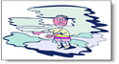1.......(mglisty) evening and she was walking home from her best friend's 2........... When she got home she took out her 3.......opened the door and  4 …..... on the 5...... Suddenly, she 6....... a big, fat bear looking at her! It had a 7. …............ of cake in its hands and a 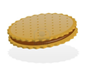 8............ in its mouth. “Oh no!” She9. …................. “There's a bear in my living room! What am I going to do?” She was sure the bear wanted to eat her, so she quickly 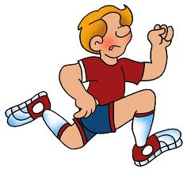10........ out of the house. She started  11...... for help, but no one 12......... her! Sally ran to the apple tree in the garden and 13.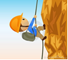…....... up as high as she could. The bear 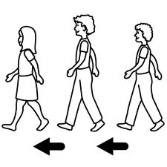14. …..... her and 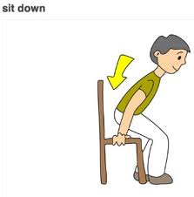 15. …... under the tree eating its 8.........Then, suddenly, the bear took its head off! Sally saw her brother with the bear's head in his hands. He couldn't stop 16..........! “As soon as I 17....... down, I'll show you!” 18 …..... Sally. “You'll never 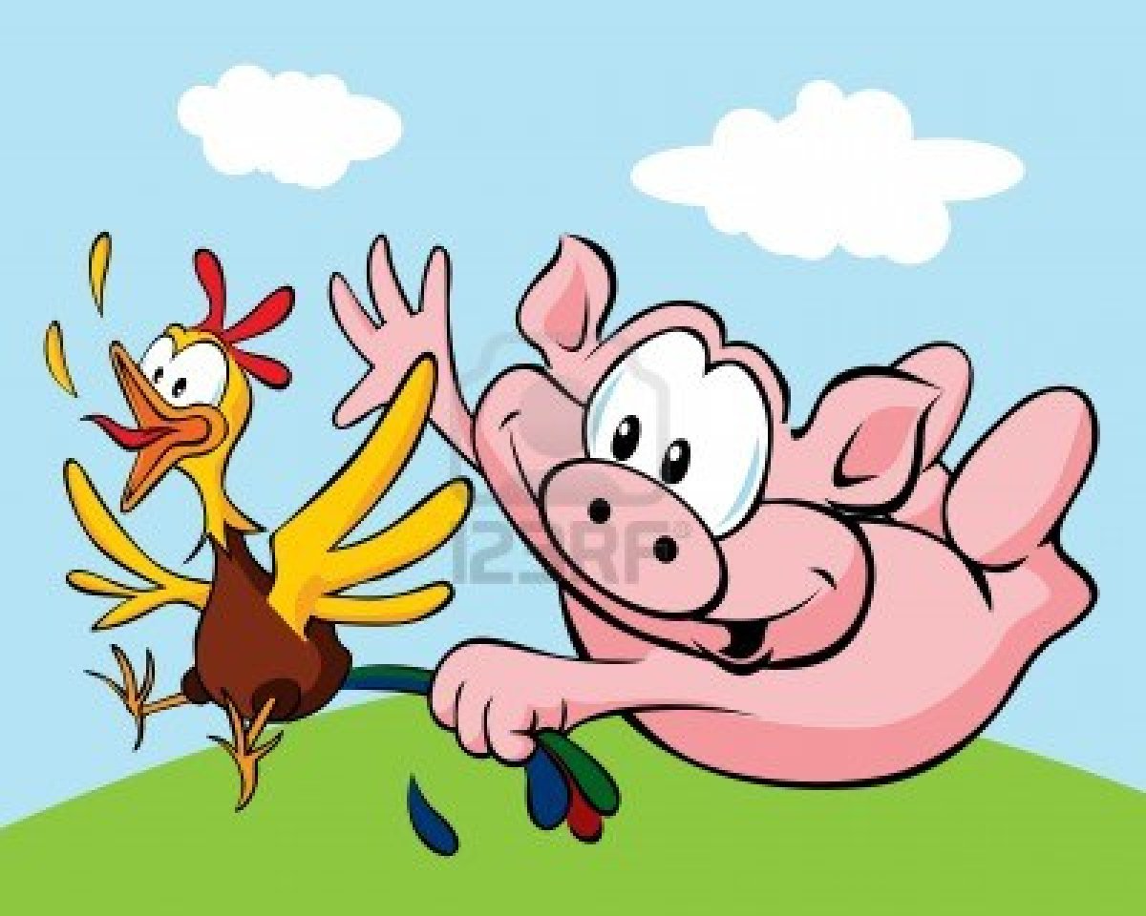 19....... (złapać).... me! You're not 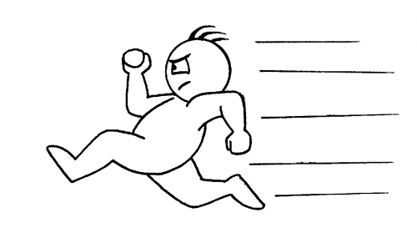20..........enough!” said Sally's brother and he 10. …... into the house, closing the21.......... 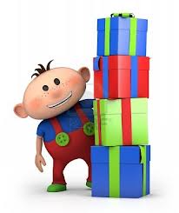22...................... him.

23. What’s the best name for this story? Tick ( √ ) one box.

A Terrible Animal

A Bear in the House

Home Alone

Adapted from Skills Builder Flyers (Prepared by Justyna Babiarz-Furmanek)
Reading

Zad 4. Przeczytaj tekst. Wybierz właściwy wyraz i wpisz w puste miejsca według przykładu. (max: 10 pkt) KARTA ODPOWIEDZI
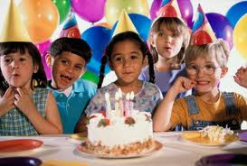
BIRTHDAY PARTIES
Example: Children always look forward .........to ......... their birthday because they
1. usually have a party. Birthday parties are a great chance to.................................
- fun with all ..................................friends from school.
- Parties......................never boring! You can have them inside in the
- winter, or outside ...................................the summer. Some children have a clown
- at their party, while others just ................................games and dance to music.
- All ………………………children that are invited usually bring a present for the
birthday girl or boy.
- There is always a ………………….to eat or drink at birthday parties!
- You will usually have a …………………..of burgers, pizza, chips and of course
- a big birthday cake. The cakes have candles on ……………….to show how
old the person is.
- Birthday parties are so …………….. fun! It’s a shame they only happen once a year.
Example at to on
1. have make had
2. your yours you
3. is isn’t are
4. on during at
5. play playing played
6. a the an
7. many much lot
8. choose choice chosen
9. them it her
10. many much few
Taken from Skills Builder Flyers 2 (Prepared by Justyna Babiarz-Furmanek)

Zad. 5. Przeczytaj uważnie podany tekst a następnie ułóż podane poniżej zdania we właściwej kolejności. (max:11 pkt) KARTA ODPOWIEDZI

MELRIC



Once upon a time there was a king, and this king had a magician. His name was Melric. Melric worked for the King. He cooked meals, repaired things, painted the castle, worked in the gardens – all by magic. He also helped other people. He was always busy. Nobody worked, except Melric.
One morning Melric got up late, he had to paint the King’s bathroom, and he was in a hurry. He said his magic words to make his bed, but nothing happened. He said the words again. Nothing.
The King was angry because Melric was late. They went into the bathroom and Melric said the magic words for painting rooms. He tried and tried, but nothing happened.
The people went home and tried to do their work without Melric’s help. Most things went wrong. They didn’t know how to cook meals, repair their things, paint their rooms, or work in the gardens and fields any more.
“I must go and see Kra, my old teacher,” Melric said.
When Melric wanted to go on a journey, he always travelled by magic. This time he had to walk. Old Kra lived in a cave in the mountains and Melric had to climb for hours.
When he came to the cave, he was very hot and tired. He sat down with Kra in front of the cave and told him his story.
“Oh, you are very silly,” said the old man.
“You lost your magic because you did not help people.”
“What?” Melric shouted. “I helped all the people in town. I cooked their meals, repaired their things, painted their rooms and did their work in their gardens and fields, whenever they asked me. I always worked for them.”
“Ha-ha. That’s the problem,” Kra said. You did everything for them. Now they don’t know how to do their work. You wanted to help, but now they are helpless.”
Melric did not say a word. Then his old teacher said. “I can give you back your magic, but you must not waste it.”
Then Kra changed Melric into a bird. “Go home now, Melric,” he told him “but don’t waste your magic.”
When Melric got home, he saw some enemy soldiers. They wanted to get into the castle. He changed himself from a bird into a magician. “Time for some magic,” Melric said. Then he changed the enemy soldiers into cats.
The people in the castle opened the doors. The castle dogs ran after the cats, and the cats ran away.
The people were very happy and the king thanked Melric, “Thank you, Melric. Tomorrow you must paint my bathroom.”
“Melric, please repair my chair,” one man shouted. Melric raised his hand. “Quiet, please. I can’t help you. You must do your work without magic. I mustn’t waste it.”
So all the people went home to do their work. They started to cook, repair their things, and to work in their gardens and fields. The King started to paint his bathroom. And Melric? Melric had to learn to make his bed.
a) Kra gave Melric his Magic back, but he said, “You mustn’t waste it”

b) He changed the soldiers into cats.

c) He went to see his old teacher, Kra.

d) Melric did a lot of work for the King and other people.

e) But Melric did not help the people with their work any more.

f) He changed Melric into a bird, and Melric flew home.

g) But one morning his magic did not work any more.

h) There, he told Kra his story.

i) The castle dogs ran after the cats.

j) Melric had to walk to Kra’s cave.

k) There he saw some enemy soldiers. They wanted to get into the castle.

Taken from Magic Time by Davis, Gerngross, Holtzmann, Puchta (Prepared by Justyna Babiarz-Furmanek)

Communication

Zad. 6. Wybierz właściwą reakcję. KARTA ODPOWIEDZI
- Excuse, me. How do I get to the leisure centre?
- Just turn left after the café.
- It's opposite the bank.
- It's miles away.
- Let's ask that man over there.

2. Thank you very much.
a) Don't thank me.
b) You're welcome.
- Yes, certainly.
d) Never mind.

3. These biscuits look delicious. Can I try one?
a) No, thanks.
b) Help yourself.
- Try it on please.
d) Yes, thank you.

4. How much are these pears?
a) There are four of them.
b) Yes, they cost a lot.
- I'll go to the grocer's then.
d) They are 70p a kilo.

5) May I go to the toilet, please?
a) No, I don’t want it.
b) Yes, you should.
c) Yes, you do.
d) Yes, you may.

6. Hi, my name's Cindy.
a) I'd like to introduce my good friend, Cindy.
b) Nice to see you again.
- It's a pleasure to meet you.
d) Have a nice day.

7. Could you pass me the bread, please?
a) Here you are.
b) I'd rather not.
- Not at all.
d) Please.

